
Name:
Calculator Free | /28 | %
Calculator Assumed | /28 | %
Total | /56 | %

Mathematics Methods, Year 12, 2018
Test 4 – Logarithmic functions and calculus involving logarithmic functions.
30 minutes working time.
Calculator Free Section (no notes, no calculators)
SCSA Formula sheet allowed
Question 1 [6 marks: 1, 2, 3]
Solve each of the following equations for $x$.
- $\log_{2}x=5$

- $ln\left(3x+1\right)= 0$

- $\ln\left(x-1\right)+\ln\left(x+2\right)=ln⁡(6x-8)$

Question 2 [5 marks: 1, 2, 2]
Express each of the following as the logarithm of a single term.
- $log 9-log 3$

- $\frac{1}{2}log36-\frac{1}{3}log27-\frac{2}{3}log8$

- $2\log{5}+2\log{2}+1$

Question 3 [4 marks]
For the following function, sketch the graph, labelling axis intercepts and asymptotes$.$
- $y=\log_{4}\left(x+4\right)+2$

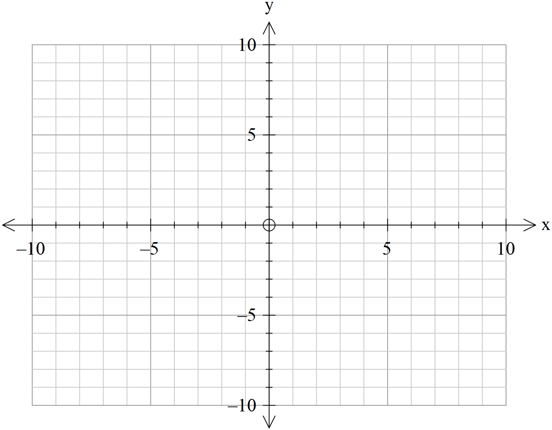

Question 4 [7 marks: 1, 3, 3]
Use common logarithms to solve for $t$.
- $4^{t}=17$

- $3^{t}= 5^{1+2t}$

- $3^{2x}+3\left(3^{x}\right)-4=0$

Question 5 [4 marks: 1, 3]
Differentiate the following:
- $y=\ln{x^{4} }$

- $y=ln\frac{1+2x}{1+x^{2}}$

Question 6 [2 marks]
Find the following integral.
$$\int{\frac{-\cos{x}}{\sin{x}}} dx$$

Name:
Total | /28 | %

Mathematics Methods, Year 12, 2018
Test 4 – Logarithmic functions, Calculus involving logarithmic functions.
Calculator Assumed Section (notes allowed) 30 minutes working time.
SCSA Formula sheet and calculators allowed
Question 7 [3 marks]
The shaded region shown in the accompanying diagram is trapped by the lines $x=2 and x=4$ and curve with equation $y=\frac{2}{x-5}+1$. Find the exact area of the shaded region.
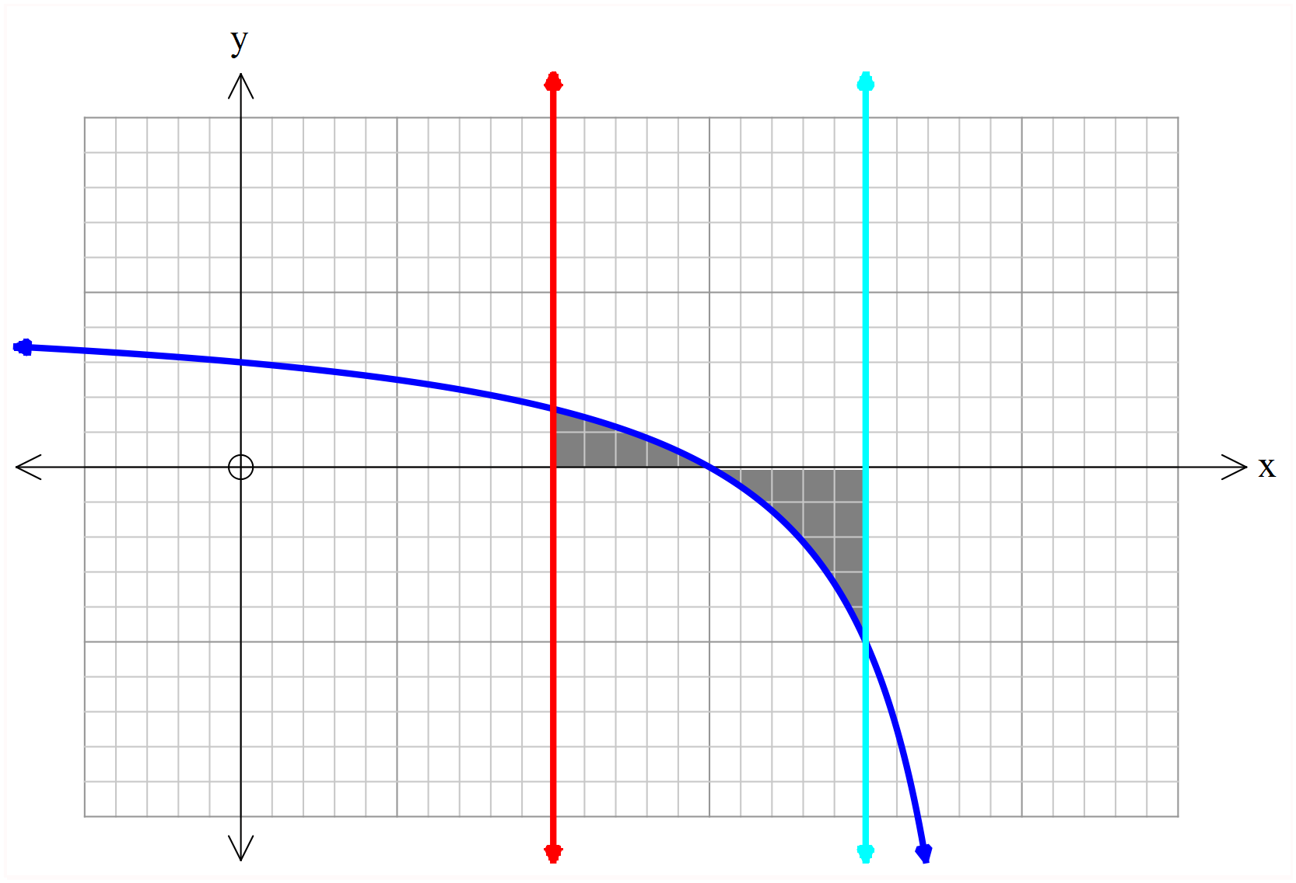

Question 8 [4 marks]

Given that $f\left(x\right)= 4x^{2}ln{ x}^{2}$. Use calculus techniques to find the exact coordinates of the stationary points on the curve $y=f(x)$

Question 9 [5 marks]
A particle moves in a straight line with acceleration $\left(a\right)$ given by
$a=\frac{8}{({t+3)}^{2}} m/s^{2}$
If the particle’s initial displacement, from rest, is zero, find, correct to one decimal place, the displacement at $t=10 seconds.$

Question 10 [9 marks: 2, 2, 2, 3]
Laura is starting a new fitness routine and she completes 2 sets of 5 repetitions of squats each day. Her aim is to get stronger and lift heavier each day.
Laura models her progress over t days by the function: $f\left(t\right)=5+k ln(t+10)$ , where $f (t)$ is the weight in kilograms of her squat each day.
- Calculate the value of k if initially Laura lifts 30 kg.

- After 2 weeks of training, by how many kilograms has her strength increased?

- Calculate the rate of change of Laura’s strength with respect to time.

- Determine when Laura’s increase in strength is half of what it was initially.

Question 11 [7 marks: 3, 2, 2]
The instantaneous rate of change of the number of fish over t weeks, being farmed in a fish farm can be modeled by $P^{'}\left(t\right)= \frac{-4970}{t+e}$ where $P(t)$ is the population after $t$weeks.
- If after 5 weeks there are 12 000 fish left, determine an expression for $P(t).$

- Calculate the initial number of fish when the study began.

- When the decline in fish each week falls below 500, the farmer is no longer as concerned for his fish stock. During which week does this occur?

